**Attendance POC**

| **Author** | **Created on** | **Last updated by** | **Last edited on** |
| --- | --- | --- | --- |
| Mohit Saini | 11-11-24 | Mohit Saini | 12-11-24 |

**Purpose**

The Attendance REST API was developed to manage and streamline all attendance-related transactions.

**Pre-requisites**

Before diving into application deployment, let’s ensure the following Hardware, Software and Security requirements are met.

**System Requirements**

| **Hardware Specifications** | **Minimum Recommendation** |
| --- | --- |
| Processor | Dual-core |
| RAM | 4GB |
| Disk | 20GB |
| OS | Ubuntu(22.04) |

**Dependencies**

**Build time Dependency**

| **Name** | **Version** | **Description** |
| --- | --- | --- |
| Poetry | Latest | Python package manager for managing dependencies |
| Liquibase | Latest | Tool for database migrations |
|  |  |  |
|  |  |  |
|  |  |  |
|  |  |  |

**Important Ports**

| **Inbound Traffic** | **Description** |
| --- | --- |
| 5432 | PostgreSQL |
| 6379 | Redis |
| 80/443 | HTTP/HTTPS |
| 8080 | API |

**Architecture**

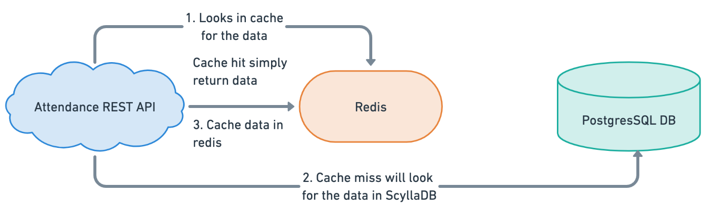

**Step-by-step installation of [application]**

**First create the instance t2.medium or t3.large.**

**Open the port**

**Update and Upgrade System Packages**

sudo apt update

sudo apt upgrade -y

**Install Python 3.11 and Dependencies**

sudo apt install python3.11 python3.11-dev python3.11-venv -y

**Install Poetry (Python Dependency Manager)**

curl -sSL [https://install.python-poetry.org](https://install.python-poetry.org/) | python3 -

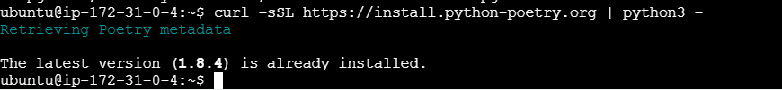

Update PATH in .bashrc

nano ~/.bashrc

export PATH="$HOME/.local/bin:$PATH"

**Check Poetry Version**

poetry --version

**Install PostgreSQL**

sudo apt install postgresql postgresql-contrib -y

**Start and Enable PostgreSQL Service**

sudo systemctl start postgresql

sudo systemctl enable postgresql

sudo systemctl status postgresql

**Install Redis Server**

sudo apt install redis-server -y

Start and Enable Redis Service

sudo systemctl start redis

sudo systemctl enable redis

sudo systemctl status redis

**Clone GitHub Repository**

git clone <https://github.com/OT-MICROSERVICES/attendance-api.git>

**Change to the Project Directory**

cd attendance-api

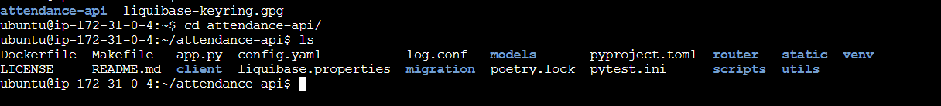

**Install Poetry for the Project**

sudo apt install python3-poetry



**Install Project Dependencies Using Poetry**

poetry install

Modify pyproject.toml to Include Specific Packages

vi pyproject.toml

change the project models as per mentioned snapshot

**Install PostgreSQL Development Libraries**

sudo apt install libpq-dev

**Show Installed Poetry Packages**

poetry show

**Install Liquibase (Database Change Management)**

sudo snap install liquibase



**Check Liquibase Version**

liquibase --version

**Run Database Migrations Using Liquibase**

make run-migrations

**Update PostgreSQL Database Using Liquibase**

liquibase --changeLogFile=db-changelog.xml --driver=org.postgresql.Driver --url=jdbc:postgresql://18.208.150.188:5432/attendance_db --username=postgres --password=password update

**change make file above mentioned line at last of make file like this**

**Download PostgreSQL JDBC Driver**

Wget [https://jdbc.postgresql.org/download/postgresql-42.5.4.jar -P /home/ubuntu/attendance-api/liquibase_lib/](https://jdbc.postgresql.org/download/postgresql-42.5.4.jar%20-P%20/home/ubuntu/attendance-api/liquibase_lib/)

**Modify PostgreSQL pg_hba.conf File for Remote Connections**

sudo vi /etc/postgresql/14/main/pg_hba.conf

**Edit Liquibase Properties**

vi liquibase.properties

**Check PostgreSQL Server Listening on Port 5432**

sudo netstat -plnt | grep 5432



Log in to PostgreSQL as postgres User

sudo -u postgres psql

**Alter PostgreSQL User Password**

ALTER USER postgres WITH PASSWORD 'password';

Create a New Database in PostgreSQL

CREATE DATABASE attendance_db;

**Run Liquibase Migrations**

liquibase --changeLogFile=db-changelog.xml update

**Install Required Python Packages Using pip**

pip install python-json-logger flaskpoetry flasgger prometheus_flask_exporter voluptuous psycopg2 redis flask-caching peewee

**Run the Flask Application Using Gunicorn**

gunicorn app:app --log-config log.conf -b 0.0.0.0:8080

**Contact Information**

| **Name** | **Email address** |
| --- | --- |
| Mohit Saini | [it.mohitsaini@gmail.com](mailto:it.mohitsaini@gmail.com) |

**References**

| **Link** | **Description** |
| --- | --- |
| https://medium.com/devops-technical-notes-and-manuals/how-to-install-and-configure-postgresql-on-ubuntu-20-04-4fd3cf072d6f | PostgreSQL installation and configuration |
| https://chandrapurnimabhatnagar.medium.com/how-to-install-liquibase-database-devops-34ca9a6d9705 | Liquibase installation |